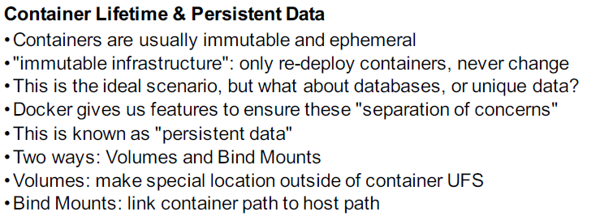

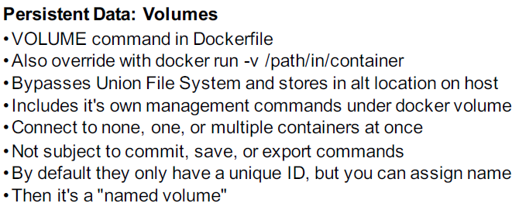

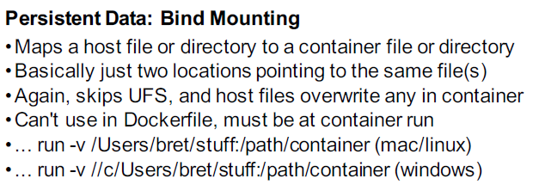

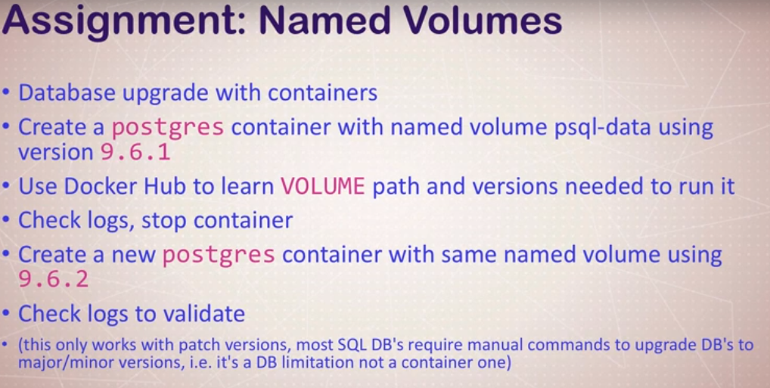

docker container run -d –name psql -v psql:/var/lib/postgresql/data postgres:9.6.1

docker container logs -f psql

docker container stop psql

docker container run -d –name psql2 -v psql:/var/lib/postgresql/data postgres:9.6.2

docker container ps -a

docker volume ls

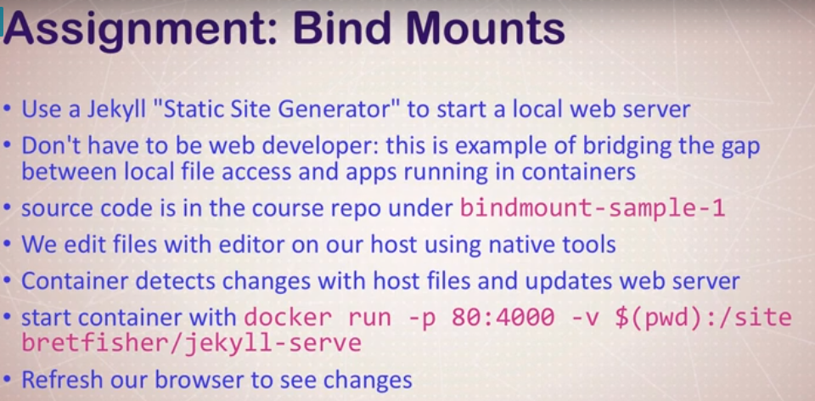

docker container run -d -p 80:4000 -v $(pwd):/site bretfisher/jekyll-serve